**The Highline Loop Hike**

|  |  |  |  |  |  |
| --- | --- | --- | --- | --- | --- |
|  |  |  |  |  |  |
|  | **Trail Features:** |  | Outstanding views, Alpine meadows, flowers | views from the Highline Loop |  |
|  | **Trail Location:** |  | Logan Pass |  |
|  | **Roundtrip Length:** |  | 11.8 Miles |  |
|  | **Total Elevation Gain:** |  | 1950 Feet |  |
|  | **Avg. Elev Gain / Mile:** |  | 331 Feet |  |
|  | **Highest Elevation:** |  | 7280 Feet |  |
|  | **Trail Difficulty Rating:** |  | 15.70 (strenuous) |  |
|  | Parking Lot Latitude |  | 48.69657 |  |
|  | Parking Lot Longitude |  | -113.71813 |  |
|  | | | | | |

**Trail Description:**  
  
The Highline Loop hike begins from the north side of the Going-to-the-Sun Road at Logan Pass. Although this hike includes the word "Loop" in its name, this is actually a one-way hike. The "Loop" refers to the bend in the road on the west side of the park where this hike ends. The best way to do this hike is to park at The Loop, located 13.1 miles east of the McDonald Lodge on the Going-to-the-Sun Road, and then take the shuttle up to Logan Pass.

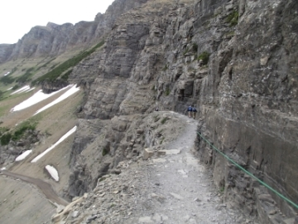The Highline Trail is an extremely popular hike; and for good reason. At every step, and every turn, hikers will have absolutely spectacular scenery as the Highline follows along the Continental Divide, also known as the Garden Wall in this area. The exceptionally beautiful views, the excellent opportunities for spotting wildlife, and the wildflowers, all combine to make this a hike you'll remember the rest of your life. If you're looking for solitude, however, you won’t find it on this trail.

Roughly one-quarter of a mile from the trailhead you'll arrive at the famous ledge with the reputation for terrifying those with a fear of heights. In most places the ledge, hanging like a shelf on the Garden Wall, is only four to six feet in width, and has drop-offs of roughly a hundred feet or so down to the Going-to-the-Sun Road below. This segment lasts for only three-tenths of a mile, but may seem forever if you have a fear of heights. Fortunately the National Park Service has installed a hand cable along this stretch of the trail. My advice is to not let this deter you, as this is one of the most scenic trails in America.

From here the trail continues to hug the cliffs and slopes of the Garden Wall, and does so for most of its length to Granite Park. Throughout the early portions of the hike Mt. Cannon, Mt. Oberlin and Heavens Peak will dominate the views towards the west.

Roughly 2.5 miles from Logan Pass the slopes of the Garden Wall begin to shallow out. Soon you'll begin the only major climb of the day, a short section of trail that takes hikers up to Haystack Pass.

At 3.6 miles, after climbing roughly 275 feet up one long switchback, hikers will reach Haystack Pass. At an elevation of 7024 feet, the pass forms the saddle between 7486-foot Haystack Butte and the Garden Wall, which at this point is technically the southeastern flank of Mt. Gould. With its outstanding panoramic views, Haystack Pass is also a popular spot for a snack or lunch break.

Beyond Haystack Pass the trail continues a gradual climb up along the Garden Wall. Soon you'll reach the highest point on the hike at an elevation of roughly 7280 feet. From this point the trail begins descending towards Granite Park. As you proceed 8436-foot Swiftcurrent Mountain eventually comes into view looking towards the north.

At 6.9 miles hikers will reach the Garden Wall Trail. This optional side trail climbs roughly 900 feet - in just six-tenths of a mile - to the top of the Continental Divide, and provides hikers with a commanding birds-eye view of The Salamander and Grinnell Glacier on the opposite side.

At 7.6 miles hikers will reach the Granite Park Trail junction. Towards the right the Highline Trail continues on towards the Fifty Mountain Backcountry Campground, roughly 12 miles away. It also leads to the [Swiftcurrent Pass Trail](http://www.hikinginglacier.com/swiftcurrent-pass.htm), roughly two-tenths of a mile away. A turn to the left will lead you down to The Loop on the Going-to-the-Sun Road. To visit the Granite Park Chalet, hikers should proceed straight ahead at this junction.

The Granite Park Chalet was built in 1914 and 1915 by the Great Northern Railway in order to provide comfortable backcountry accommodations inside Glacier National Park. The rustic lodge was the last of the nine chalets built by the railroad, and today is listed as a National Historic Landmark. Compared to Sperry Chalet, the Granite Park Chalet is much more basic, and is essentially a simple hiker's hostel, with virtually no amenities. It has 12 guest rooms, each with 2 to 6 bunks. There’s no electricity, but the common-area kitchen does have a propane stove where you can cook a warm lunch or dinner.

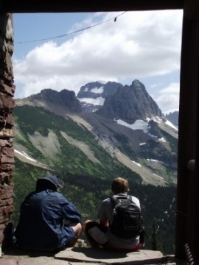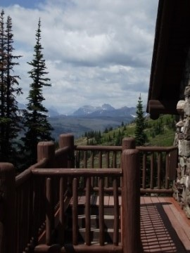

The chalet also sells packaged foods, beverages, snacks, and bottled water to hikers. If not interested in buying water, there's a stream about a quarter-mile away along a rough and rugged trail. You will have to treat this water first. For more information and to make a reservation, please [click here](http://www.graniteparkchalet.com/).

To continue towards the Loop on the Going-to-the-Sun Road, hikers will now begin to follow the Granite Park Trail. A little more than a half-mile from the chalet you'll reach the spur trail that leads to the Granite Park Backcountry Campground, which includes 4 individual campsites.

As you proceed down the Granite Park Trail, also known as the Loop Trail, you'll pass through a couple sections of pine forest. Once beyond this forested area, just below the chalet, the terrain begins to open up again. The massive 8987-foot Heavens Peak will dominate the views across the valley. Below the mountain is the McDonald Creek Valley. In this same area, roughly 9 miles from Logan Pass, you'll also begin to notice the devastation inflicted by the 2003 Trapper Creek Fire. In many places, alongside the trail and across the valley, are the ghostly remains of thousands of dead trees.

Prior to 2003 the Granite Park Trail passed through heavily wooded terrain, but the lightning ignited wildfire, which burned more than 19,000 acres, swept through and opened up vistas of the surrounding mountains. The forest, however, is already in the process of regeneration. Today you'll find extensive undergrowth, including thousands of wildflowers.

At 11.2 miles hikers will finally reach the bottom of the descent at the Packers Roost Trail junction. To continue on towards The Loop trailhead, take a left at this fork and walk another half-mile to reach a footbridge. From here the trailhead is only a tenth-of-a-mile away.

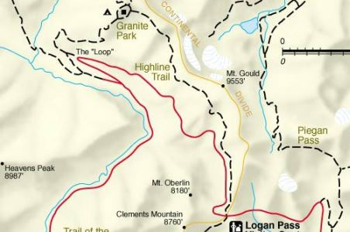

**Ptarmigan Tunnel**

|  |  |  |  |  |  |
| --- | --- | --- | --- | --- | --- |
|  |  |  |  |  |  |
|  | **Trail Features:** |  | Outstanding views, Alpine Lake, Historic | Ptarmigan Tunnel |  |
|  | **Trail Location:** |  | Iceberg Lake Trailhead |  |
|  | **Roundtrip Length:** |  | 10.7 Miles |  |
|  | **Total Elevation Gain:** |  | 2300 Feet |  |
|  | **Avg. Elev Gain / Mile:** |  | 430 Feet |  |
|  | **Highest Elevation:** |  | 7255 Feet |  |
|  | **Trail Difficulty Rating:** |  | 15.30 (strenuous) |  |
|  | Parking Lot Latitude |  | 48.79958 |  |
|  | Parking Lot Longitude |  | -113.67924 |  |
|  | | | | | |

**Trail Description:**

The hike to Ptarmigan Tunnel begins behind the cabins near the Swiftcurrent Motor Inn. There's enough parking for roughly 10-15 cars in the lot next to the trailhead. However, given the popularity of the area, it's likely the lot will be full, in which case you'll have to park in front of the Swiftcurrent Motor Inn. This will add another two-tenths of a mile walk to reach the trailhead.

Just beyond the Iceberg Lake Trailhead hikers will immediately turn right at a junction to access the short connector trail that leads to the Ptarmigan Trail. This connector trail is a fairly steep climb, gaining roughly 185 feet in only a quarter-of-a-mile. However, once on the Ptarmigan Trail, the gain in elevation is much more moderate.

Upon reaching the Ptarmigan Trail junction, hikers should turn left. A turn to the right will lead you back down to the Many Glacier Hotel.

Along the upper reaches of the connector trail, as well as on the early sections of the Ptarmigan Trail, hikers will have commanding views of 8851-foot Mount Grinnell and 8436-foot Swiftcurrent Mountain towards the southwest. The dominating feature towards the west is 9321-foot Mount Wilbur, and lying towards the northwest, in the direction you're heading at this point, is the Ptarmigan Wall.

The Many Glacier area, especially the Ptarmigan Trail area, is located in prime bear habitat. The first mile or so past the connector is a haven for grizzly bears. Nearly every time that I've hiked this trail I've spotted at least one along the hillside. It's extremely important for hikers to make a lot of noise, carry [bear spray](http://www.amazon.com/Bear-Deterrent-w-Holster-8-1oz/dp/B002J94MMM/ref=as_li_wdgt_js_ex?&linkCode=wsw&tag=hikinginthcom-20), and hike in groups in this area. As a result of its location, trails in the Many Glacier area are frequently closed due to bear activity. Thus, it's always a good idea to check with a ranger on the status of a trail before proceeding on any hike in the park.

The first segment of the hike passes through open terrain that offers grand views of the surrounding mountains. However, as you proceed further along, the trail enters a fairly dense section of pine forest, roughly 1.5 miles from the trailhead.

At 2.5 miles hikers will reach a small clearing overlooking Ptarmigan Falls. Unfortunately this is the best view of the falls you'll have, as steep terrain makes it virtually impossible to get a closer look. Moreover, tree cover blocks a full view of the falls from top to bottom.

Just above Ptarmigan Falls is an open and rocky area that has become a popular spot for a snack break or a rest stop.

Shortly after passing the falls you'll cross a footbridge over Ptarmigan Creek. Roughly a tenth-of-a-mile later you'll reach the [Iceberg Lake Trail](http://www.hikinginglacier.com/iceberg-lake.htm) junction, which takes hikers to one of the most beautiful alpine lakes in the park. Turning right and continuing on the Ptarmigan Trail will lead hikers to the Ptarmigan Tunnel.

With most people heading towards Iceberg Lake, this segment of the Ptarmigan Trail won't be nearly as heavily traveled as the first section.

Beyond the junction hikers will begin another fairly steep climb of more than 400 feet over the next six-tenths of a mile. This section also passes through a thick patch of huckleberries. This is another place where you'll need to make a lot of noise in order to avoid a surprise encounter with a bear.

Once this relatively short ascent is completed, the saddle above the Ptarmigan Tunnel will be directly ahead of you. Shortly thereafter you'll emerge from the treeline and views of the Ptarmigan Wall will become even more dramatic. The Ptarmigan Wall, towering more than 1700 feet above the trail at this point, is known as an arête, defined as a thin ridge of rock separating two valleys that have been carved by glaciers. In this case, the Ptarmigan Wall separates the Many Glacier valley from the Belly River valley.

Roughly 4.2 miles from the trailhead you'll reach a series of waterfalls and cascades tumbling down Ptarmigan Creek in the valley below the trail. Just beyond this point is Ptarmigan Lake. Although the main trail continues above the shore, there's a short side trail that drops down to the foot of the lake. Bighorn sheep and mountain goats are frequently seen in this area.

From here you can see the final segment of the trail as it climbs two major switchbacks towards the tunnel. Some might find this climb a little daunting. Above the lake the trail gains roughly 500 feet in less than two-thirds of a mile. However, the spectacular views that await you from both sides of the tunnel should provide enough motivation to push you onward.

Upon arrival at the tunnel's south entrance hikers will have commanding views of Ptarmigan Lake and the glacially sculpted, U-shaped valley between the Ptarmigan Wall and Crowfeet Mountain. Beyond the valley, Mt. Wilbur is the dominating feature.

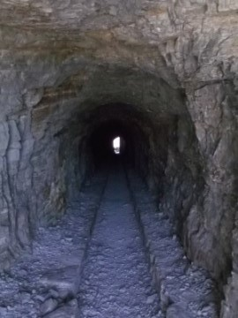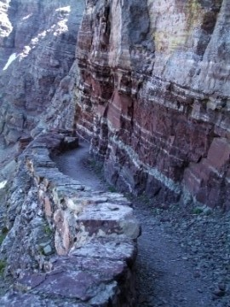

Walking to the other side of the tunnel is like walking into another world. Hikers will have stunning views of Natoas Peak, Crosley Ridge, and the Belly River as it flows into Elizabeth Lake. Walk a little further down the trail, as it hugs the red rock face of Crowfeet Mountain, and you'll be able to see Old Sun Glacier on the slopes of 10,004-foot Mt. Merritt towards the west.

The 240-foot Ptarmigan Tunnel was originally built by the Civilian Conservation Corp in the 1930's for horses and early park tours. Using two opposing steel jackhammers drilling from either side of the tunnel, and a series of dynamite charges, workers broke through the mountain in less than three months. The blasted rock was used to build doorway entrances, also known as adits, on each end of the tunnel, as well as retaining walls alongside the trail. In 1975 the National Park Service added steel doors to both ends of the tunnel, which now remain closed between October 1st and the opening of the trail, usually around the middle of July.

In 1998 a woman lost her life on the north side of Ptarmigan Tunnel in one of the most freakish accidents in Glacier National Park history. The Polson, Montana woman, along with her husband and two companions, rode horseback to the tunnel from Many Glacier. Upon arrival they led their horses through the tunnel to view the scenery on the other side. While standing beside the low stone parapet her horse abruptly jerked and stumbled, and knocked the woman onto the retaining wall. The horse then lost its footing and fell on top of her. Both horse and rider then rolled over the wall before falling hundreds of feet to their deaths.

